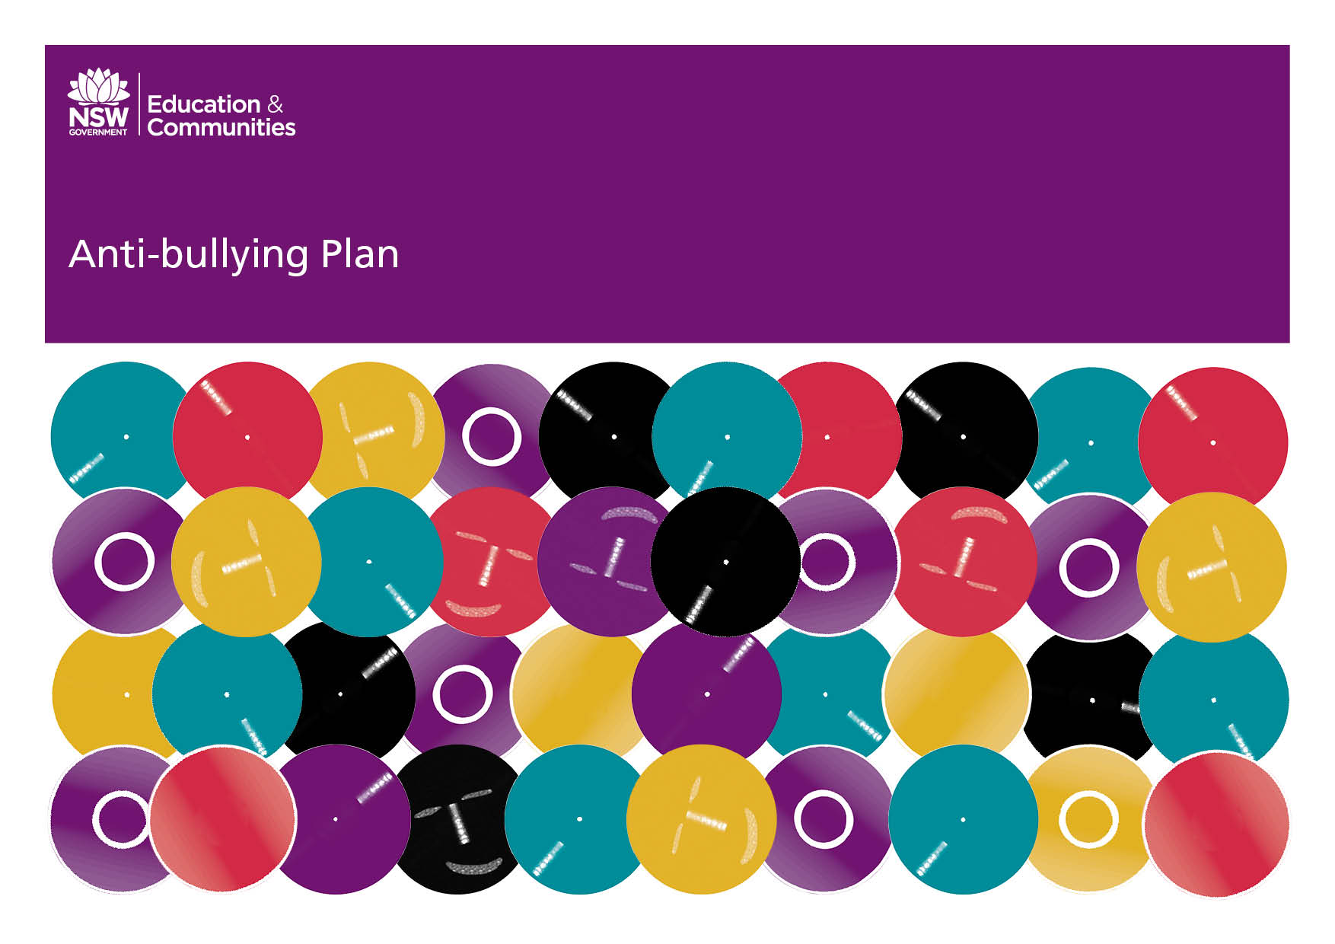
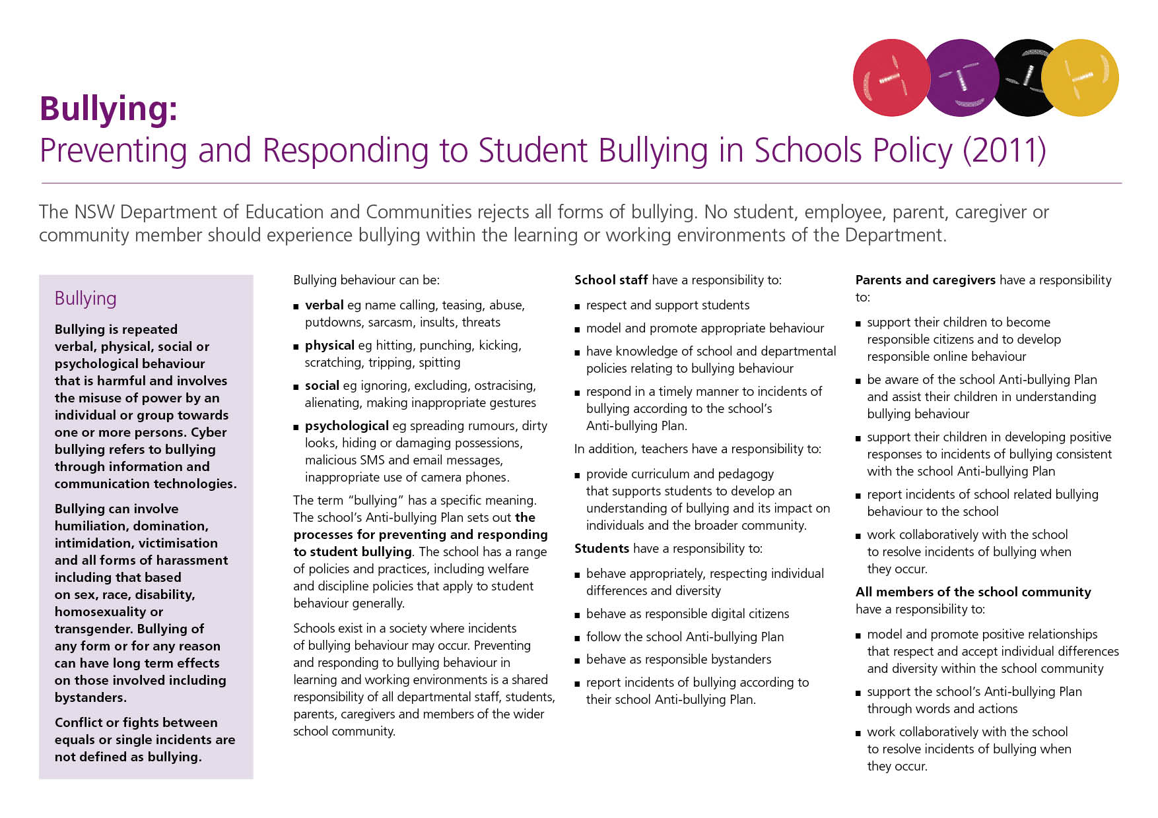
Our School Anti-Bullying Plan
Northmead Public School 2016

Our School Anti-Bullying Plan
This plan outlines the processes for taking reasonable steps to prevent and respond to student bullying in our school and reflects the Bullying: Preventing and Responding to Student Bullying in Schools Policy of the New South Wales Department of Education and Communities.
Northmead Public School is an inclusive environment, where diversity is affirmed and individual differences are respected. Quality education is provided for students to meet their learning needs in a secure, ordered and supportive school environment. Partnership with students, parents, staff and the wider community is considered central to the success of addressing bullying when it occurs in our school community.

School Vision: We as a collaborative learning community seek to promote a safe, compassionate and stimulating school environment in which everyone is inspired to think critically while developing the necessary skills to become empowered to achieve to their potential as a caring, resilient and productive citizen in the twenty first century.

Strategic Direction 1: Provide an educational experience that challenges students to achieve their fullest potential.
Strategic Direction 2: The basis for improving student learning outcomes is high quality teaching and leadership.
Strategic Direction 3: Students, their achievements, and their wellbeing drive all decisions and actions.

Statement of purpose
Northmead Public School students fully engage in high quality teaching and learning practices which are specifically designed to assist them to develop pro-social skills and academic competencies. These attributes enable them to take responsibility for their own learning and behaviour, and ultimately allow students to engage with, and contribute to the wider Australian community.

For students to positively engage in the educational opportunities at Northmead Public School they each have a right to learn in an environment where they are safe and free from harassment or intimidation. Any inappropriate behaviour that inhibits another student’s right to learn or otherwise interferes with their well-being will be addressed by the school as per the school’s behaviour policy.

Protection

Bullying is defined as repeated verbal, physical, social or psychological behaviour that is harmful and involves the misuse of power by an individual or group towards one or more persons. Cyberbullying refers to bullying through information and communication technologies.
Bullying can involve humiliation, domination, intimidation, victimisation and all forms of harassment, including that based on sex, race, disability, homosexuality or transgender. Conflict or fights between equals, or single incidents, are not defined as bullying.

There are many forms of bullying, but those listed below are some examples of the most common.

1. Physical:
Repeated: hitting, punching, kicking, pinching, tripping, spitting, scratching or throwing objects at someone

2. Verbal:
Repeated: name calling, abuse, put-downs, teasing, sarcasm, insults, threats

3. Psychological:
Repeated: spreading rumours, dirty looks, hiding or damaging possessions, gossiping about or embarrassing someone

4. Social:
Repeated: ignoring, ostracising, alienating, excluding, making inappropriate gestures

5. Cyber (Online Bullying):
Repeated: malicious SMS or email messages, inappropriate use of camera phones or social media

Bullying behaviour typically contains seven elements:
1. An initial desire to hurt.
2. Bullying desire is acted out repeatedly.
3. This action is hurtful.
4. There is an imbalance of power - either physically or psychologically.
5. There is no justification for the action - i.e. the victim has done nothing to deserve such treatment.
6. It is persistent and repeated.
7. The person bullying derives enjoyment from hurting the victim.

Schools exist in a society where incidents of bullying behaviour may occur. Preventing and responding to bullying behaviour in learning and working environments is a shared responsibility of all department staff, students, parents, caregivers and members of the wider school community.

All staff have a responsibility to:
- model and promote appropriate behaviours;
- teach students skills and strategies to deal with bullying;
- respond to reported and observed incidences of bullying as set out in this plan and the school's discipline policy; and
- report incidences of bullying to the Assistant Principal, Deputy Principal or Principal consistent with school welfare reporting procedures.

All students have a responsibility to:
- behave appropriately, respecting individual differences and diversity;
- behave as responsible digital citizens;
- report incidences of bullying to a staff member; and
- report cases of cyber-bullying that occur during school hours to a staff member. Cyber-bullying incidents that occur out of school hours need to be reported directly to the police.

All parents/caregivers have a responsibility to:
- support their children to become responsible citizens and to develop responsible on-line behaviour;
- be aware of the school Anti-Bullying Plan and assist their children in understanding bullying behaviour;
- support their children in developing positive responses to incidents of bullying consistent with the school Anti-Bullying Plan; and
- report incidents of school related bullying behaviour to the school;
- work collaboratively with the school to resolve incident of bullying when they occur.

Prevention and Early Intervention
Northmead Public School is committed to providing a safe and caring environment that fosters respect for others.

Positive Behaviour For Learning (PBL)
Our student learning, anti-bullying and wellbeing policies are underpinned by the principles of PBL
Expectations for student behaviour are clearly defined and reinforced. Appropriate student behaviour is taught during PBL lessons and a whole school rule focus. Positive behaviours are publicly acknowledged and effective behavioural support is implemented consistently by staff (including administration, Learning Support Officers, canteen, cleaners and administration). Inappropriate behaviour has clear and predictable consequences. Student behaviour is monitored and staff receive regular feedback.
The main ideas of PBL:
- To focus on student engagement
- Preventative emphasis
- A system based intervention
- A problem solving framework
- Promotion and application of evidence-based interventions
- Inclusive of all students
- Supports the curriculum

Our school is part of the PBL initiative. Our school Core Values are:
- Be Safe
- Be Respectful and
- Be a Learner.

At Northmead Public School we aim to:
- create a culture where it is acceptable and encouraged to report incidents of bullying;
- empower students by listening to their experiences;
- promote a positive learning environment that fosters safe, respectful learners;
- promote the reporting of bullying incidents by students involving themselves or others;
- encourage parents to contact the school if they have a concern; and;
- recognise and reward students for positive behaviour and resolution of problems.

Strategies that are used to promote a safe and positive learning environment within the school:
- Regular positive reinforcement of appropriate behaviour in classrooms, playground and assemblies.
- Teaching of behaviour expectations through PBL lessons, signage around the school and PBL initiatives.
- Participation in anti-bullying, cyber safety, child protection and/or life education programs.
- Implementation of school based reward systems.

Response
When an alleged bullying incident is reported, the following strategies will be employed;
- An investigation of the reported incident will take place within a reasonable timeframe to ascertain whether report is of bullying (see definition earlier in policy), poor social skills or rule breaking.
- Where an alleged incident is found to be bullying, the appropriate executive staff will be notified and consequences applied as per the school’s behaviour policy.
- Where practical, both bullies and victims will be offered support.
- If student bullying persists, the principal will commence formal disciplinary action.
- Incidents related to bullying will be recorded. Actions taken to address the incidents will be noted.
- Where appropriate, parents and caregivers will be informed of the management of specific incidents, within the bounds of privacy legislation.

Communication
We are all extremely fortunate to be part of Northmead Public School community. Home and school communication is essential in assisting our school’s children with the best possible academic and social development. Parents are always encouraged to support their child’s school life through making regular contact with the school. As we guide students through their academic studies, we are also equally guiding them in developing their social and interpersonal skills. From time to time, it is necessary to assist students in recognising the better choice to make, whether it is to fulfil a commitment, make some kinder choices in the way they treat their peers or even respond respectfully to teachers and all staff. When anger, jealousy, resentment and even annoyance become evident, it often requires some self-reflection.
The following is our current school practice and will give you some direction.
- Classroom Teacher: is always the first and best professional person with whom to speak regarding academic progress, social or behavioural concerns, class policy and procedures.
- Assistant Principals: If the question relates to a specific issue that is outside of the classroom, any questions regarding specific grade or department programs, issues relating to discipline / bullying, concerns that have not been resolved by speaking with the classroom teacher or queries relating to teaching and learning within the classroom.
- Deputy Principal: Any issues that relate to the whole school, child protection and student welfare, community, issues that have not been resolved first through discussions with the classroom teacher and /or the Assistant Principal.
- Principal: Any issues that relate to the whole school, child protection and wellbeing, governance and management, financial and budgeting, community, issues that have not been resolved first through discussions with the classroom teacher and /or the Assistant Principal or Deputy Principal.
Student Support Officers
Student Support Officers work within the school community in partnership with the learning and support team and school counselling service to enhance student social and emotional wellbeing and learning outcomes. Student Support Officers provide both whole-of-school wellbeing initiatives and targeted strengths-based supports for students requiring personalised assistance. They also have a pivotal role in working collaboratively with external child and family support agencies and other government agencies to support students and their families.
Evaluation/Review
The plan and strategies adopted by the school are evaluated on an ongoing basis as well as formally reviewed at least once every three years. This process may include:
- analysis of behaviour and PBL data
- analysis of the frequency of reported and observed incidences of bullying
- consultation with major educational stakeholders
Cyberbullying

Cyberbullying is commonly defined as the use of information and communication technologies to support repeated and deliberate hostile behaviour intended to harm others. It is sometimes used as an extension to other forms of bullying, and can result in the target of bullying experiencing social, psychological and academic difficulties.
Cyber Safety: The vast majority of social media platforms require the participants to register only after they turn 13 years of age. Therefore, there shouldn’t be any children at our school accessing Facebook / Instagram etc. Each service provider has their own way to manage complaints and cyber bullying and there is also the e-safety commissioner who has their own processes and can help to remove material from social media sites.
Forms of cyberbullying
■ Flaming – heated exchange
■ Harassing and threatening messages eg ‘text wars’, ‘griefers’
■ Denigration – sending nasty SMS, pictures or prank phone calls ‘Slam books’ (websites or negative lists)
■ Impersonation Using person’s screen name or password eg message to hate group with personal details
■ Outing or trickery – sharing private personal information, messages, pictures with others
■ Posting ‘set up’ images/video eg ‘happy slapping’
■ Ostracism – Intentionally excluding others from an online group eg knocked off buddy lists
■ Sexting – sharing explicit material by mobile phone.

Cyberbullying: What can schools do?
■ Maintain a school climate where bullying is less likely to take place and students feel comfortable reporting cyberbullying.
■ Implement a sustained curriculum approach to address: - appropriate use of technology (Digital Citizenship) - bullying (including cyberbullying issues)
■ Develop, with their school community, clear, well publicised policies addressing: - use of technology - preventing, reporting and managing bullying and cyber bullying.
■ Develop programs for those students in need of additional support with the development of communication, social and relationship skills, or digital citizenship.
■ Contact the Police and the School Safety and Response Unit where incidents of cyberbullying include possible criminal behaviour.
■ Keep accurate records of incidents and their management.
■ Survey students to monitor bullying and cyberbullying rates.
■ Ensure all members of the school community including casual staff are familiar with the school’s anti-bullying plan.
■ Identify students with bullying behaviour or who have experienced bullying both on and after enrolment and develop strategies to support them.
■ Promote anti-bullying messages throughout the school community.
■ Bystander Training: a proactive strategy that trains bystander students to behave in a supportive way to students are being bullied, to intervene where feasible or to report the incident to a teacher.

School executives, Learning Support Teams or Student Welfare Teams will decide on which intervention, or combination of interventions, is appropriate to each individual circumstance of cyberbullying. Note: No method of addressing bullying has been reported as 100% effective.

Additional Information
Additional information, resources and support relating to effective anti-
bullying strategies can be found at-
- Bullying. No way! www.bullyingnoway.com.au
- Kids Help Line www.kidshelpline.com.au
- Reach Out! www.reachout.com.au
- Bullying Among Young Children: A guide for parents by the Australian
- Attorney General’s Department.
- Anti-bullying https://detwww.det.nsw.edu.au/lists/directoratesaz/stuwelfare/ behaviourprgms/antibullying/index.htm
- Digital Citizenship http://www.digitalcitizenship.nsw.edu.au
- Cybersmart Teachers Gateway and kids portal www.cybersmart.gov.au Teacher Resources – Cybersmart http://www.cybersmart.gov.au
- Friendly schools friendly families www.friendlyschools.com.au/

The Department of Education provides a policy and guidelines for handling complaints, the Complaints Handling Policy. This policy establishes the standard approach to resolving complaints, including complaints about the way a reported incident of bullying has been managed and it is required that it be used in all learning and working environments of the Department of Education. It is important to note that reasonable disciplinary action conducted in a reasonable manner does not constitute bullying.

For matters involving bullying which affect departmental employees, refer to the department’s Prevention of Bullying in the Workplace Policy (intrant only).

Principal’s comment
Northmead Public School is an inclusive environment. The school openly celebrates diversity and individual student differences are respected and valued.

Northmead Public School actively seeks to ensure all students receive an education which caters to their individual student learning needs in highly supportive and safe environment. A cornerstone of the school’s Anti Bullying Policy is its inclusiveness. The views, values and beliefs of parents, caregivers, and students are reflected in this policy and therefore central to its success

School contact information

Northmead Public School
Moxhams Rd, Northmead NSW 2152
Phone 9630 3133
Fax 9890 1796
School Email | northmead-p.school@det.nsw.edu.au
School Website | www.northmead-p.schools.nsw.edu.au

