Kindergarten 2018 Orientation Information



**Kindergarten Orientation Dates**

|  |  |
| --- | --- |
| **Orientation Session 1** | **Wednesday 15th November** |
| **Orientation Session 2** | **Wednesday 22nd November** |
| **Orientation Session 3** | **Wednesday 29th November** |

**Parent Information Session**

**Wednesday 8th November**

**Time: 5:00pm-6:00pm**

**Place: School hall**

**Refreshments 6pm – 6:30pm**

**Best Start Assessment Appointments**

You will receive a Best Start Assessment letter in December detailing your child’s appointment day and time. The ‘Best Start’ assessments will be undertaken on:

|  |  |
| --- | --- |
| **Tuesday 30th January** | **9:00am – 3:00pm** |
| **Wednesday 31st January** | **9:00am – 3:00pm** |
| **Thursday 1st February** | **9:00am – 3:00pm** |

The Best Start assessment will take between 30 minutes to complete. Parents are not able to sit in on the assessment but are welcome to wait outside the classroom while the assessment is being completed.

A Guide for parents on Best Start Literacy and Numeracy <http://www.schools.nsw.edu.au/languagesupport/documents/best_start/literacy.php>

<http://www.schools.nsw.edu.au/languagesupport/documents/best_start/numeracy.php>

**Procedures for the first day of school — 2018**

* Kindergarten children start on **Monday 5th February 2018**
* Parents and children meet in the **HALL at 9.30am.**
* Classes will be read out at this time.
* Parents are invited to walk with the children to the door of the classroom but are asked **NOT** to go in.
* Parents are invited to attend a morning tea which will be in the school hall, starting at 10.00am
* Dismissal from school will be at **3.00pm.**
* Children will be taken out onto the verandah by the teacher.
* Parents are asked **NOT** to enter the room or collect their child’s bag.
* Children will be handed over to parents.

|  |  |  |
| --- | --- | --- |
|  |  |  |

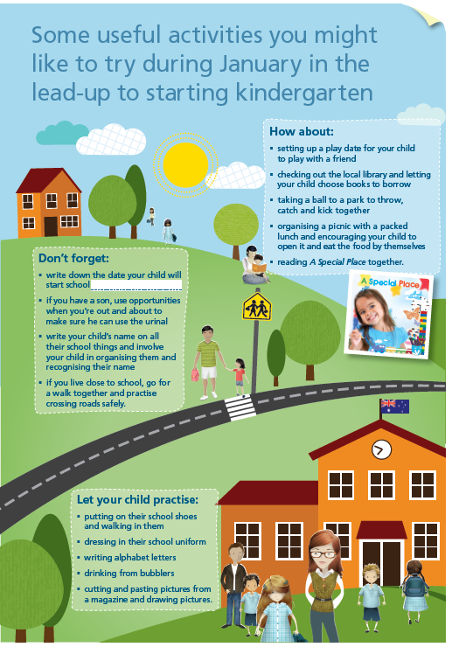

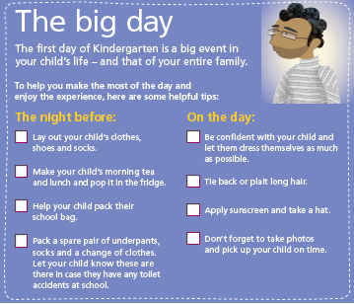

Preparing for Kindergarten:

* <http://www.schools.nsw.edu.au/gotoschool/primary/primaryindex.php>

This Children’s picture book is written for you to read with your child starting Kindergarten:

* <http://www.schools.nsw.edu.au/media/downloads/schoolsweb/gotoschool/primary/a-special-place.pdf>

Getting Ready for School Booklet:

* <http://www.schools.nsw.edu.au/media/downloads/schoolsweb/gotoschool/primary/gettingreadyforschool.pdf>

**Kindergarten 2018 Orientation**

This program is designed to facilitate the positive transition of children from the preschool/home setting into Kindergarten.

The staff of Northmead Public School demonstrates, by participation in this program, a commitment to providing a positive beginning to a child’s school life.

The staff also acknowledges, by participation in this program, the importance of developing parents’ trust and confidence in the educational setting they have chosen for their children.

**Outcomes for Students**

The Northmead “Kindergarten 2018 Orientation Program” prepares the preschool child for:

* the physical environment of a Kindergarten Classroom
* a large group setting
* movement to and from the classroom
* toileting in the school setting
* the physical environment of the playground
* play in the school playground
* separation from parents/caregivers
* involvement with school staff

**Outcomes for Parents**

The Northmead “Kindergarten 2018 Orientation Program” ensures parents are confident and happy when bringing their children on the first day of school because they are:

* familiar with the physical environment of the school e.g. locations of Canteen, Office, Library.
* familiar with all school routines e.g. arrival/dismissal procedures.
* familiar with playground procedures
* familiar with children’s toileting procedures
* familiar with classroom procedures
* fully informed about school uniforms
* fully informed about children’s daily classroom requirements

Tips to help parents with school aged children:

* [](http://www.google.com.au/url?sa=i&rct=j&q=&esrc=s&source=images&cd=&cad=rja&uact=8&ved=0ahUKEwjum7jr9NHPAhVE2GMKHc8DBLoQjRwIBw&url=http://www.skolahovorcovice.cz/ms/posledni-zpravy/369&bvm=bv.135475266,d.cGc&psig=AFQjCNE02jvy338kXQwdDCxcvvXXmvrVLg&ust=1476246479307915)<http://raisingchildren.net.au/>

**Outcomes for Staff**

* Staff are familiar with the children prior to the school year
* Staff are fully informed by parents about the special needs of the children prior to the beginning of the year.
* Staff are able to begin the Kindergarten program sooner because the time taken to settle children into school is reduced.



**Overview of the Kindergarten 2018 Orientation Program**

* The program provides for the gradual transition of students over 3 sessions. During the visits the children participate in a variety of classroom activities.
* Parents are fully informed about school procedures and requirements.
* Parents are given the opportunity to meet members of the Parents and Citizens Association.
* Opportunities are provided for the purchase of school uniforms.
* Parents are given the opportunity to discuss any concerns about children and school procedures with the Early Stage 1 Assistant Principal.
* Parents are given access to the school website [www.northmead-p.schools.nsw.edu.au](http://www.northmead-p.schools.nsw.edu.au) which will provide them with information about school procedures and routines.

**Northmead Public School**

**Important Procedures and Information**

* Your child must attend school regularly. All absences must be explained, in writing. Please ensure the date of the absence is included in the note.
* The school must be contacted prior to another adult picking up your child.
* The school under no circumstances follows an instruction to place a child in a taxi.
* Any medical requirements must be provided to the school in writing to the school office and discussed with the class teacher.
* No medication is to be in the child’s possession.
* If parents are unavoidably detained in the afternoon, the school must be contacted before 3pm. Children will be taken to the Office to wait for their parents.
* The school has a NO HAT – PLAY IN THE SHADE rule. Hats must be worn at all times when in the playground.
* Appointments must be made to discuss issues with the teachers. Please avoid discussing matters with the teacher at 9:00am. It is very difficult to talk to a teacher when she or he has the responsibility of a class.
* The school must be informed of changes of address and telephone numbers. Emergency contacts must be current.
* If you are arriving late or departing early from school, you must bring your child to the Office.

|  |  |
| --- | --- |
| **Bell Times at Northmead Public School** | |
| 8:40am | A teacher is on playground duty.  Children are not able to be at school before this time |
| **8:55am** | [Image result for clipart image cool teacher and children](http://www.google.com.au/url?sa=i&rct=j&q=&esrc=s&source=images&cd=&cad=rja&uact=8&ved=0ahUKEwikjryJlM_PAhWBxJQKHT7AA84QjRwIBw&url=http://www.clipartkid.com/teaching-line-cliparts/&bvm=bv.135258522,d.dGo&psig=AFQjCNEwG4VzDHLM6GmfQKK-smpmoP_evg&ust=1476151773542462)A bell is rung to remind students to use the toilet. Music is played for students to make their way to their class line up area. |
| **9:00am** | School begins |
| **11:00- 11:30am** | RECESS  [Image result for clipart image crunch and sip](http://www.google.com.au/url?sa=i&rct=j&q=&esrc=s&source=images&cd=&cad=rja&uact=8&ved=0ahUKEwjkrreRls_PAhXFkJQKHSBFADYQjRwIBw&url=http://settlers.wa.edu.au/index.php?page%3Dstarting-kindergarten&bvm=bv.135258522,d.dGo&psig=AFQjCNG62u2Rj6K7wlvrTA95ORf0dlufNg&ust=1476152332755423)**11:00—11:10am:** Eating time. Children are not able to play during this time.  **11:10—11:30am:** Play time. |
| **12:50-1:40pm** | LUNCH  **12:50-1:00pm:** Eating Time  **[Image result for clipart image children of playing](https://www.google.com.au/url?sa=i&rct=j&q=&esrc=s&source=images&cd=&cad=rja&uact=8&ved=0ahUKEwid56OPwc_PAhVBUWMKHdk7ApEQjRwIBw&url=https://www.pinterest.com/geminabutler/images-of-kids-at-play/&bvm=bv.135258522,d.amc&psig=AFQjCNFXlRTyKhR4xMxyz7bJmSZVe-l3tw&ust=1476163859109511)1:00 – 1:40pm:** Play time |
| **3:00pm** | End of school day |

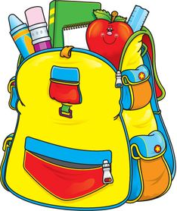**Children’s Requirements**

**For Kindergarten next year your child will need…**

* A school bag, preferably a back-pack. School back packs are available from the clothing shop, which will adequately hold all school requirements.
* A school hat – Our school has a policy of ‘NO HAT- PLAY IN THE SHADE’.
* Lunch box - The size of the lunch box is important. Too large a box hinders independence in removing the box from the school bag. Please also discuss with your child which food is for Crunch & Sip, recess and lunch. Please ensure your child is able to open and close his or her own containers independently.
* A drink bottle of water is essential.
* Crunch & Sip – A small amount of freshly cut fruit and vegetables and/or water, not fruit juice. You might like to put Crunch & Sip into a separate container.
* Raincoat – preferably with a hood. (Umbrellas are not recommended due to the safety issues).
* Spare underwear and socks.
* Painting smock - The student needs to be familiar with how to put on the smock.
* Children will be provided with pencils. They do not need a pencil case.
* All belongings need to be **CLEARLY LABELLED** with your child’s name and class. When labelling belongings, please remember to label all parts of the item, especially those which are detachable, such as lunch box and drink bottle lids.

Ideas for school lunchboxes:

* <http://www.schoolatoz.nsw.edu.au/wellbeing/food/recipes>
* <http://www.healthykids.nsw.gov.au/>

**Kindergarten Weekly Activities**

**Library:** Students will visit the library once a week and be able to borrow books.

**Sport:** Sport will be held once a week and will focus on fundamental movement skills. A Gymnastics and Dance program will also be offered.

**Assembly:** Students will participate in an assembly once a fortnight in the school hall. Parents are welcome.

**Scripture/Ethics:** Students will attend a Scripture or Ethics class once a week.



**What your child will learn at school**

Kindergarten is the foundation year for developing children’s literacy and numeracy skills.

There are six subjects (known as Key Learning Areas) studied in Kindergarten and throughout school:

* English
* Mathematics
* Science and Technology
* Creative Arts
* Human Society and Its Environment (History and Geography)
* Personal Development, Health and Physical Education

**You can find more information from the following websites:**

* [www.boardofstudies.nsw.edu.au/parents](http://www.boardofstudies.nsw.edu.au/parents)
* <http://www.schoolatoz.nsw.edu.au/>

[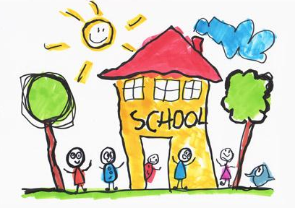](http://www.google.com.au/url?sa=i&rct=j&q=&esrc=s&source=images&cd=&cad=rja&uact=8&ved=0ahUKEwiny6Pqg9LPAhViVWMKHcJKDOAQjRwIBw&url=http://www.clipartkid.com/getting-ready-for-school-cliparts/&bvm=bv.135475266,bs.2,d.cGc&psig=AFQjCNGMGbBpGNRKaddD4M34XrvfZ494AQ&ust=1476250141050966)